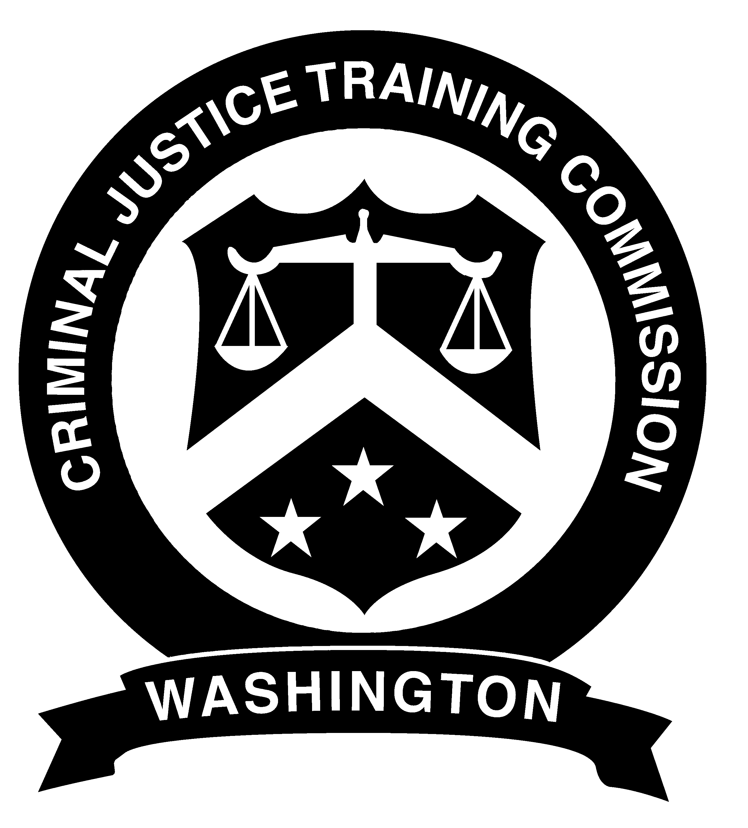

PEACE OFFICER CERTIFICATION
APPLICATION

Form CJ 1904
Rev: 01-28-2013

FAX: 206/835-7923

Name in Full: (Last, First, Middle) | Student ID: | Social Security No.

Current Agency

Training – Enter date of completion (MM/DD/YY)

Basic Academy Equivalency

RCW 43.101.095 requires that as a condition of continuing employment as a peace officer, all Washington peace officers shall timely obtain certification as peace officers, or timely obtain certification for exemption therefrom, by meeting all of the requirements of RCW 43.101.095 and RCW 43.101.200. As a prerequisite to certification, each peace officer must provide signature on this form, authorizing the release to the Commission of personnel files, termination papers, criminal investigation files, or other files, papers, or information that are directly related to a certification matter(s) that may come before the Commission.

The Commission may deny or revoke certification of any peace officer, after written notice and hearing, based upon finding of one or more of the following conditions:
- Failure on the part of the peace officer to meet all of the requirements under RCW 43.101.200.
- The peace officer has knowingly falsified or omitted material information on an application for training or certification to the Commission.
- The peace officer has been convicted at any time of a felony offense under the laws of this state or has been convicted of a federal or out-of-state offense comparable to a felony under the laws of this state.
- The peace officer has been discharged for disqualifying misconduct, the discharge is final, and some or all of the acts or omissions forming the basis for the discharge proceedings occurred on or after January 1, 2002.
- The peace officer’s certification was previously issued by administrative error on the part of the Commission.
- The peace officer has interfered with an investigation or action for denial or revocation of certificate by: (a) knowingly making a materially false statement to the Commission; or (b) in any matter under investigation by or otherwise before the Commission, tampered with evidence or tampered with or intimidated any witness.

I have reviewed and acknowledge the conditions in which my certification may be denied or revoked and hereby authorize the release of information required by the Commission under RCW 43.101.095 to establish and maintain my certification as a peace officer in Washington State.

Applicants Signature__________________________ Date __ __

