
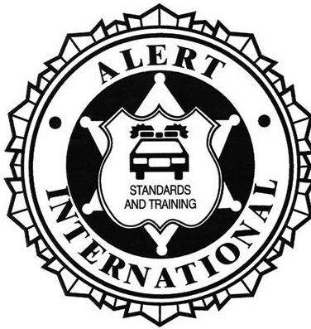

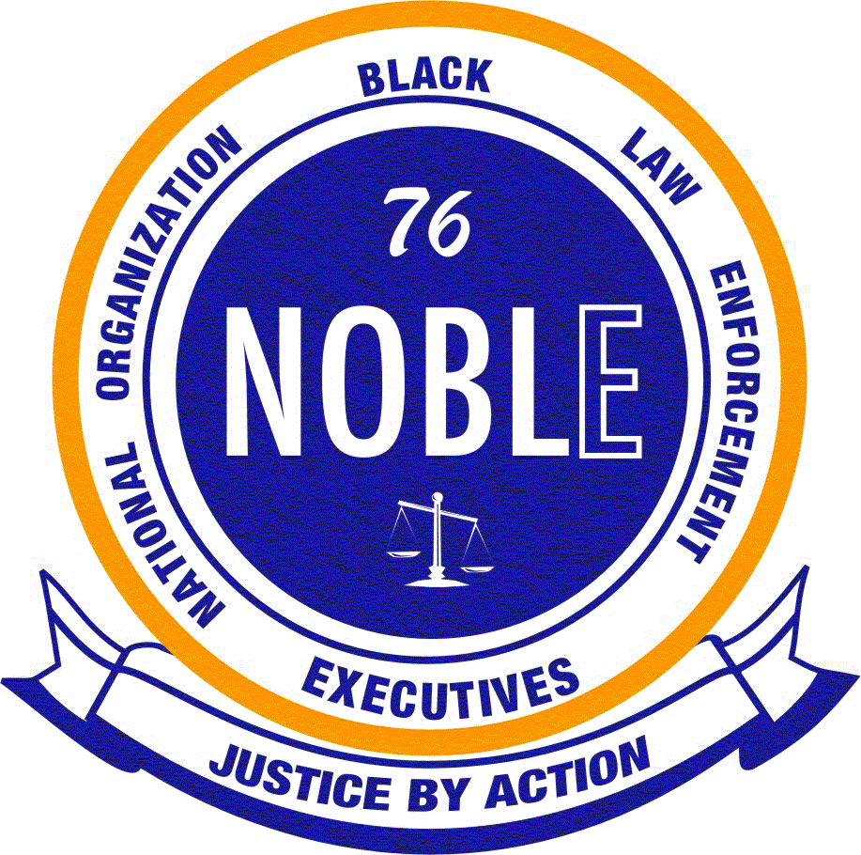
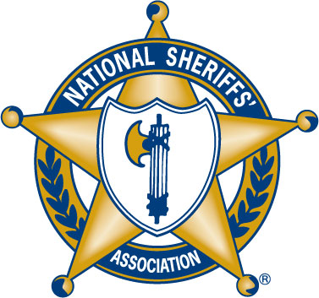
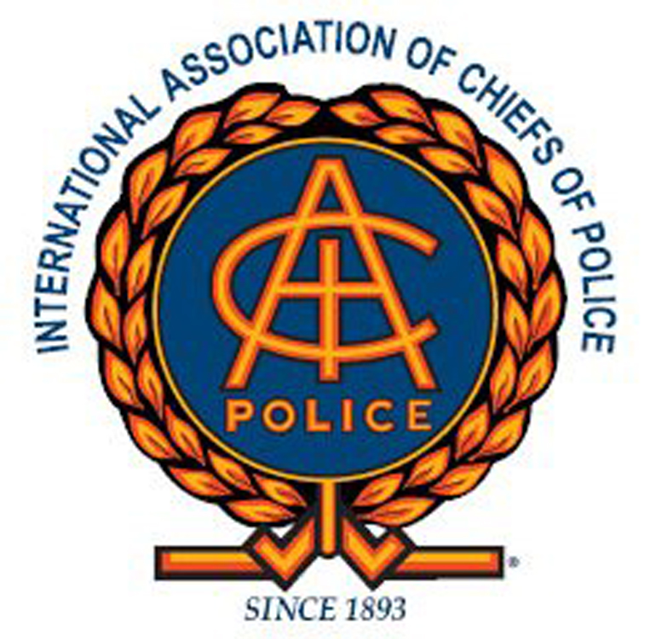
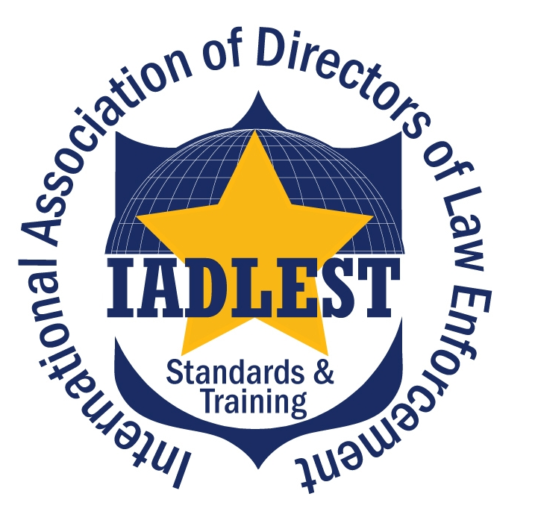

This certifies that

[Name]
has successfully completed the 4 hour
Pursuit Policy Workshop

[Date]

Workshop INSTRUCTOR:

[Instructor]
In an effort to reduce the number of deaths and injuries resulting from vehicle pursuits, the National Highway Traffic Safety Administration is partnering with ALERT International, IADLEST and other supporting organizations. Techniques discussed in pursuit policy courses are consistent with the International Association of Chiefs of Police guidelines.

